Drew King

CSD340 MOD1

GitHub Stage, Commit, & Push

03/20/21

Link to repository: <https://github.com/drew-king82/csd-340/blob/main/module-1/README.md>

Screenshot of Github:

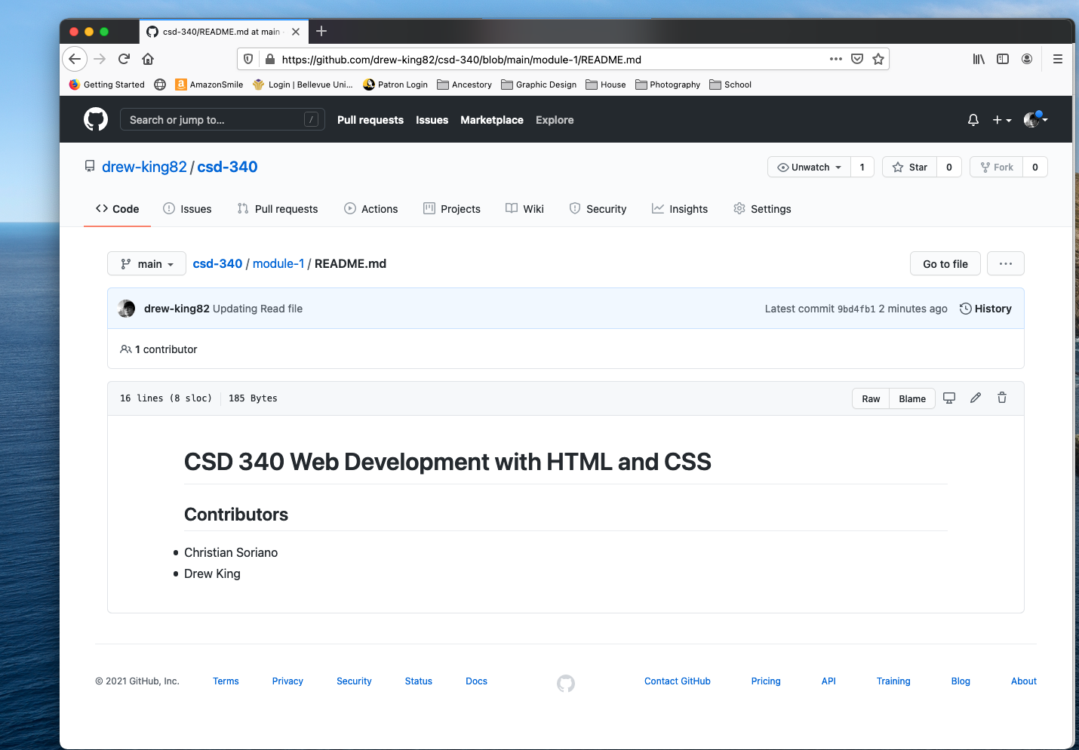

Screen shot of local directory:

